Bold BI – On boarding

# Activate Password

1. Check your email inbox. (Email which you entered for registering to this session).
2. Click on “ACTIVATE” button.

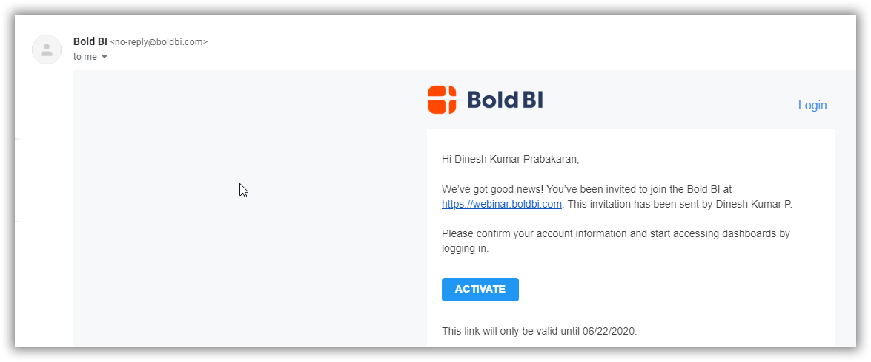

1. You would be having a tab opened in your browser like this to activate password for your email to login Bold BI; In “Company name” – you can enter your college name as needed.

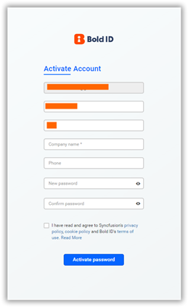

# Login the Bold BI application

1. Upon activating the password, you can now login into <https://webinar.boldbi.com/> with the username (email) and password (generated in previous step)

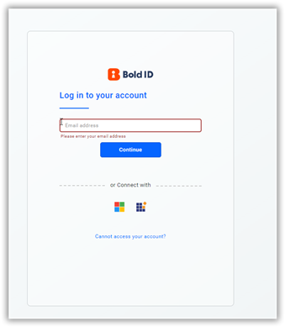

1. Upon successful login, you will be navigated to the home page of Bold BI - <https://webinar.boldbi.com/bi/en-us/dashboards?view=all>

# Creating first dashboard

1. Click on + icon,

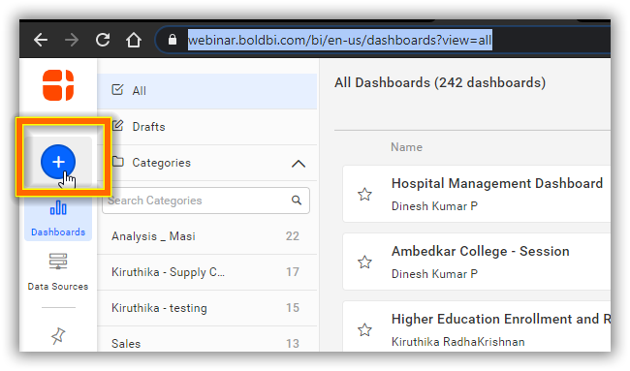

1. Choose “Start from Scratc”

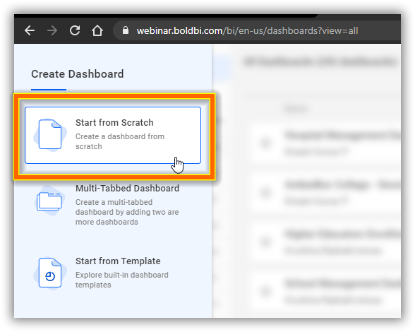

1. Enter a name. For uniqueness and quickly identify your dashboard, you can append with your own name. And then click “Add and Design”.

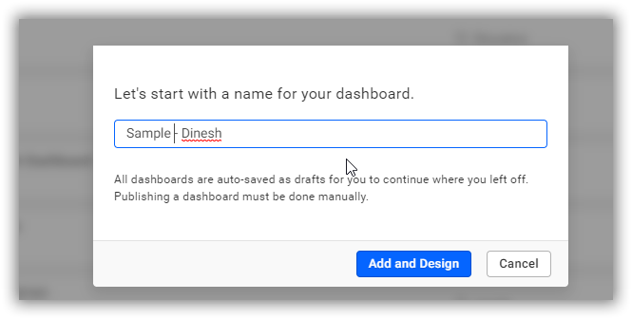

1. You will be landed in empty Dashboard Designer window.

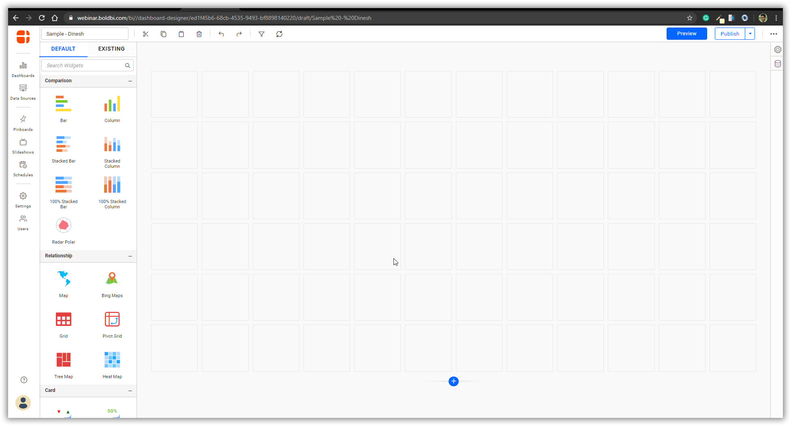

Further to this step, we can do it in live during the session.